A Rabbi, a Prophet, and a King Walk into a Bar

and other
Jewish Stories Every Person Should Know
Day, Date, Time, Place
Stories that Reveal Jewish Humor, Tradition, and Values

Sandy Schuman is a storyteller, musician, and educator. He tells stories about songs and song-writers, personal adventures, historical sagas, folk tales, and stories in the Jewish storytelling tradition.

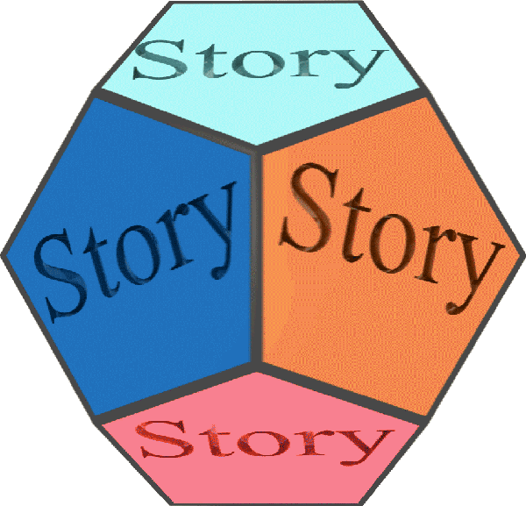  www.tothestory.com | Venue logo | Sponsor logo

