 | Familiar Songs and their Unfamiliar Stories
Featuring the “Song of the Century”
Day, Date, Time, Place
Learn how some of the best-known American songs came to be written. This program features songs from the Great American Songbook and stories about the people who wrote them – Harold Arlen, Irving Berlin, George and Ira Gershwin, Jay Gorney, E. Y. Harburg … Sing along, if you like!
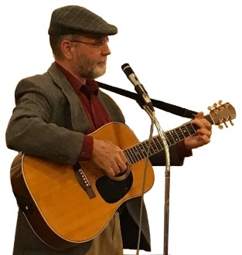
Sandy Schuman is a storyteller, musician, and educator. He tells stories about songs and song-writers, personal adventures, historical sagas, folk tales, and stories in the Jewish storytelling tradition.
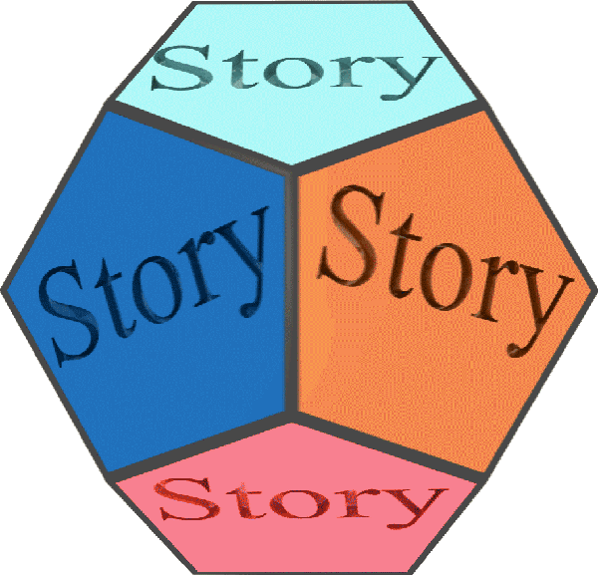  www.tothestory.com | Venue logo | Sponsor logo

